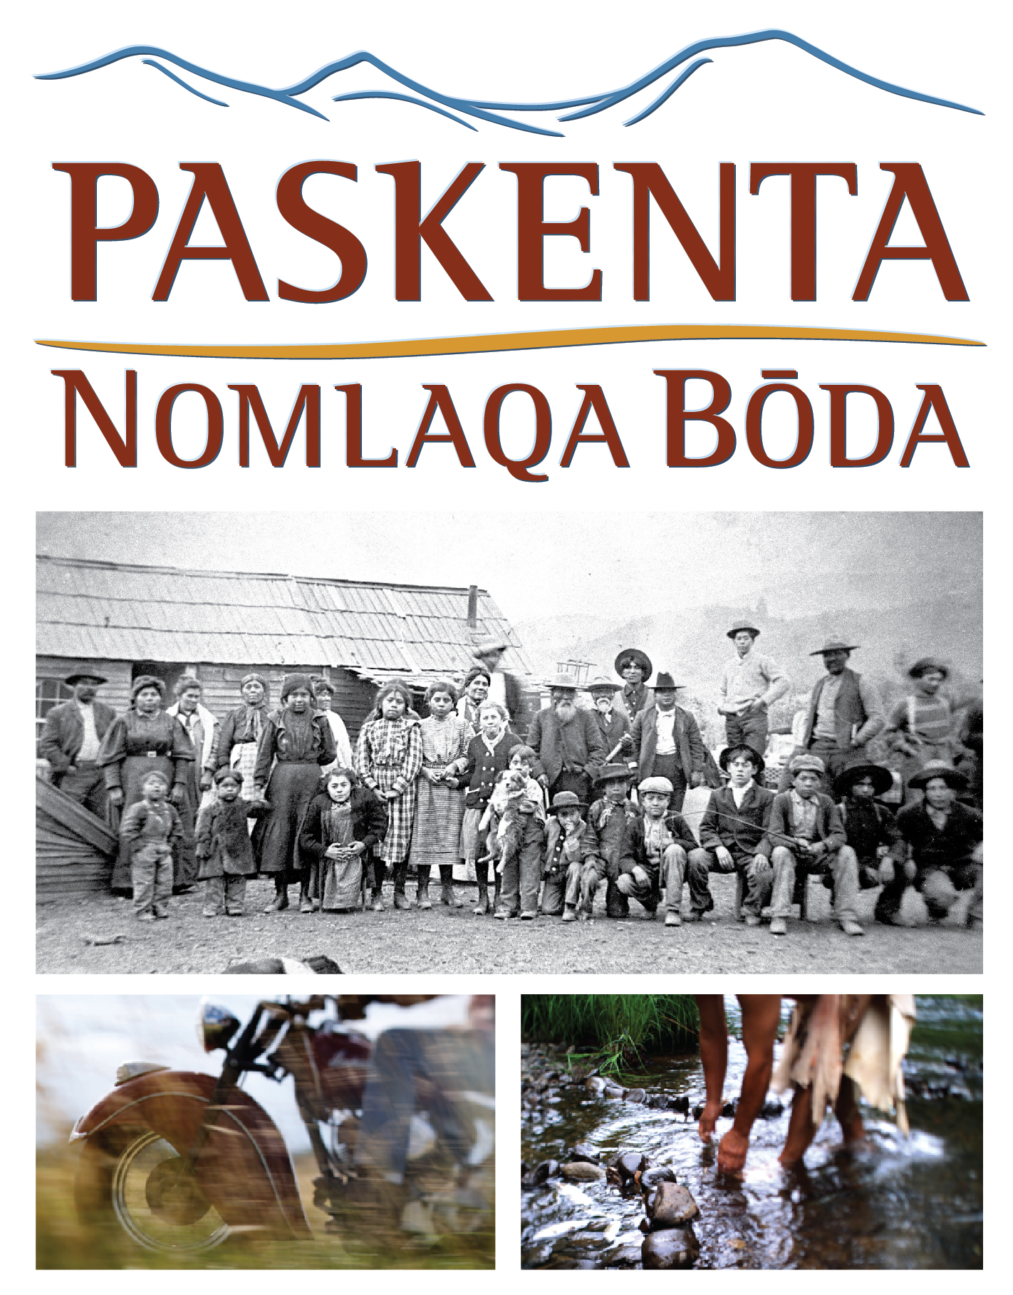
Screening at the Tulsa International Film Festival
3:45 p.m. Friday, September 23 (Q&A to follow)
6 p.m. Saturday, September 24 (Q&A to follow)
Director’s Row 3, Hyatt Regency, 100 E. Second Street, Tulsa

ABOUT DAWSON MEDIA GROUP
Dawson Media Group (DMG), based in Portland, Ore., creates high-quality, mission-based media including private and public artworks, non-profit messaging, documentary production, and educational multimedia for museums, schools and other venues.
Our focus and experience is in working with educational institutions and publishers, government agencies and national non-profit institutions to create content-rich digital media for distribution across multiple platforms. We do not produce projects that promote violence, sell consumer products, or devalue human lives, morals or ethics.
With more than 20 years’ experience as producers of national primetime programming for PBS, Discovery, and other major broadcasters, DMG’s Creative Director, Harry Dawson, and Executive Producer, Meighan Maloney, are experienced in developing and producing engaging and high-quality video and other digital media assets that will stimulate discussion among viewers. We view every project as an opportunity to develop an engaging narrative, create beautiful visuals that enhance the story, and combine it all with excellent editing and motion graphics. We work in all media and delivery platforms: Film, Digital, HD video, Web, DVD and emerging technologies.
Some of DMG’s current projects include:
- Pushing the Limits produced in partnership with Dartmouth College, Califa, and the Association of Rural and Small Libraries, featuring video segments for use in book club settings in rural public libraries (funded by the National Science Foundation).
- Cinematography for Mary and The Martyrs, two commissioned film artworks for permanent installation in London’s St. Paul’s Cathedral, directed by Bill Viola.

- PaskentaEd, commissioned by the Paskenta Band of Nomlaki Indians and in partnership with the National Center for History in the Schools (UCLA) includes the development of standards-based, American history lesson plans infused with content about the Nomlaki and other northern California tribes.
- Examining the Evidence, probing the ethics, history and science behind today’s forensic science, in partnership with Twin Cities Public Television (funded by the National Institute of Justice).
To learn more about Dawson Media Group, visit our Web site at www.dawsonmediagroup.com or call us at 503.477.7462

