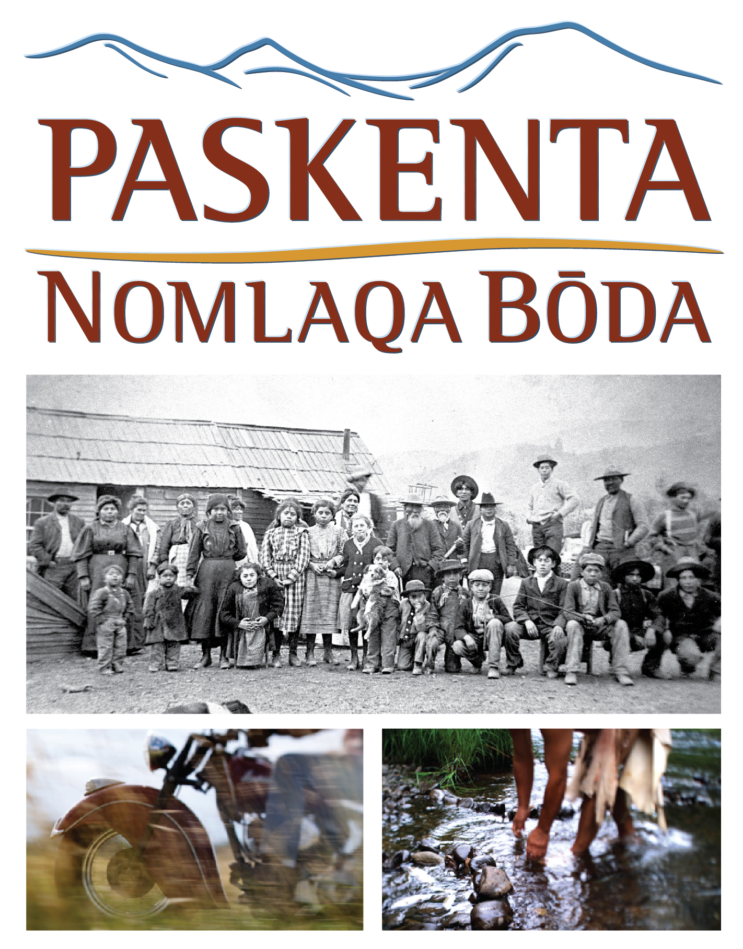
Screening at the Tulsa International Film Festival
3:45 p.m. Friday, September 23 (Q&A to follow)
6 p.m. Saturday, September 24 (Q&A to follow)
Director’s Row 3, Hyatt Regency, 100 E. Second Street, Tulsa

HARRY DAWSON
Director & Cinematographer
Harry Dawson, Dawson Media Group co-founder, cinematographer and visionary leader, first began his work with the Tribes in 1971, when—as a recent graduate—he directed and produced Little White Salmon Indian Settlement profiling a band of Yakima occupying an in-lieu site on the Columbia River.
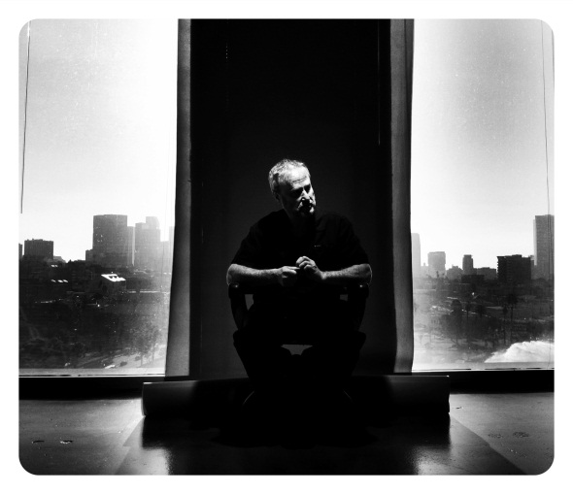
His second film was The People Are Dancing Again, which contributed to the re-recognition efforts of the Siletz Tribe by
the federal government. In the past 30 years his work has often returned to native stories and is featured in permanent exhibits in the Plains Indian Museum in Cody, Wyoming and the Tamástslikt Cultural Institute.
Harry has a long history of shooting nationally broadcast projects including NOVA, FRONTLINE, and numerous Discovery Channel documentaries, and he has contributed cinematography to feature films such as Management (with Jennifer Aniston) and the box office hit Twilight. He is a member of the Cinematographer’s Guild,
IATSE 600.
In addition to his extensive documentary production experience, works with Bill Viola in film and digital cinema creating “video artworks for fine art settings.”
Dawson’s work with Viola has been showcased at the Guggenheim Museum, MOMA, the Metropolitan Museum of Art in New York City, The Getty Center in Los Angeles and the National Portrait Gallery in London, England, and is held in many private collections. Harry’s cinematography has been favorably reviewed in the LA Times, American Cinematographer, The New Yorker and the London Times.

