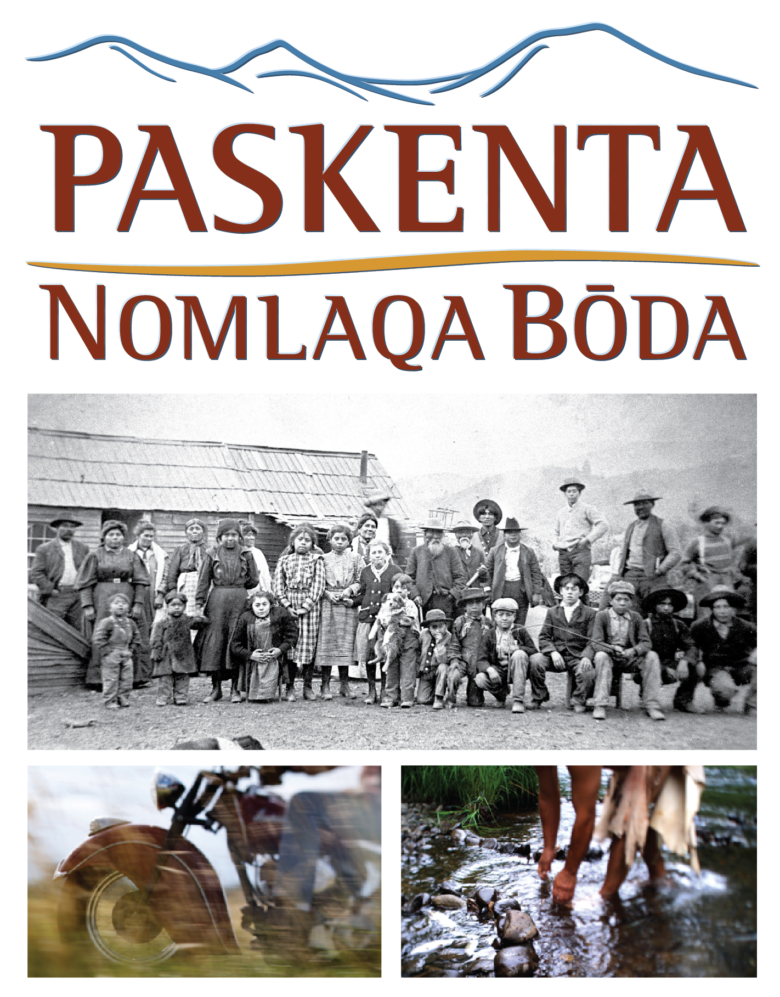
Screening at the Tulsa International Film Festival
3:45 p.m. Friday, September 23 (Q&A to follow)
6 p.m. Saturday, September 24 (Q&A to follow)
Director’s Row 3, Hyatt Regency, 100 E. Second Street, Tulsa

MAKING THE FILM
Paskenta: Nomlaqa Bōda was shot with a combination of high-definition and digital cinema cameras. Since a low profile camera was preferred for intimacy, we began the project in 2006 with an HVX200, shooting 720p. While we were getting to know the tribal members during the early months of filming, this small, less obtrusive camera was an asset. This small camera allowed a shot never seen before, a two shot in the cab of a pick-up!
As the film began to have a shape, we realized there needed to be a series of historical “vignettes”—depictions of scenes created from oral histories and primary source documents. We wanted these scenes to be distinctly different from the rest of the film in look and feel. A RED ONE camera with a swing-shift lens system was the choice. This piece of equipment allowed Harry Dawson (DP) to select a certain part of the frame to be in focus, while the remainder of the frame obscured, creating a pushing back of reality for a feeling of another time. Adding to the effect was a 24fps frame rate, as the rest of the film was shot 30fps. Additional footage was also acquired with the Panasonic AJ-HDX900 in 720p.
We felt it was absolutely critical that all Indian roles be played by Native Americans. We knew this would be a challenge because there are so few Nomlaki (about 300). We worked with a Native American talent coordinator (Crystal Shade, Tolowa) who contacted Native peoples throughout Oregon, Washington and California and requested their assistance in casting the film. By the end of filming we were privileged to hire more than 45 Native women, men and children from numerous tribes across the northwest. Some of the Native American actors traveled a half-day’s drive to our shoot locations, showing their support for the Nomlaki tribe and the importance of the story being told. Many of the Native actors expressed that the film resonated with them personally, because of the shared history struggle and triumph.
In keeping with the goal of telling a story that reflects contemporary Nomlaki identity, we wanted to combine traditional song with a modern underscore. The original score was inspired by a Nomlaki melody, sung by Cody Pata (Nomlaki) in the opening of the film. The other pieces by composer Cal Scott, all grew from this starting point and were developed in consultation with Mr. Pata.
The writing of the film was an organic process. Since we had started the work with the intention of simply creating a collection of oral histories, we had a lot of material that was seemingly disparate. As the project evolved into a feature documentary, the challenge was to build narrative arcs that would both fit into a linear film and retain the essence of the non-linear nature of oral histories, drawing on the stories we already had, and gathering other stories necessary for the script.
We felt it extremely important that the story be told by those who had lived it—through their own and their family’s experiences—and we determined fairly early on to put the film together without a narrator. Our original rough cut was much more focused on the events of the Removal, but by working with the Tribal Council and Mr. Pata we re-shaped the film to cover a broader time span. . Fortunately we were given excellent access by the interview subjects and were able to conduct multiple interviews with many of them, over the four years of shooting.

