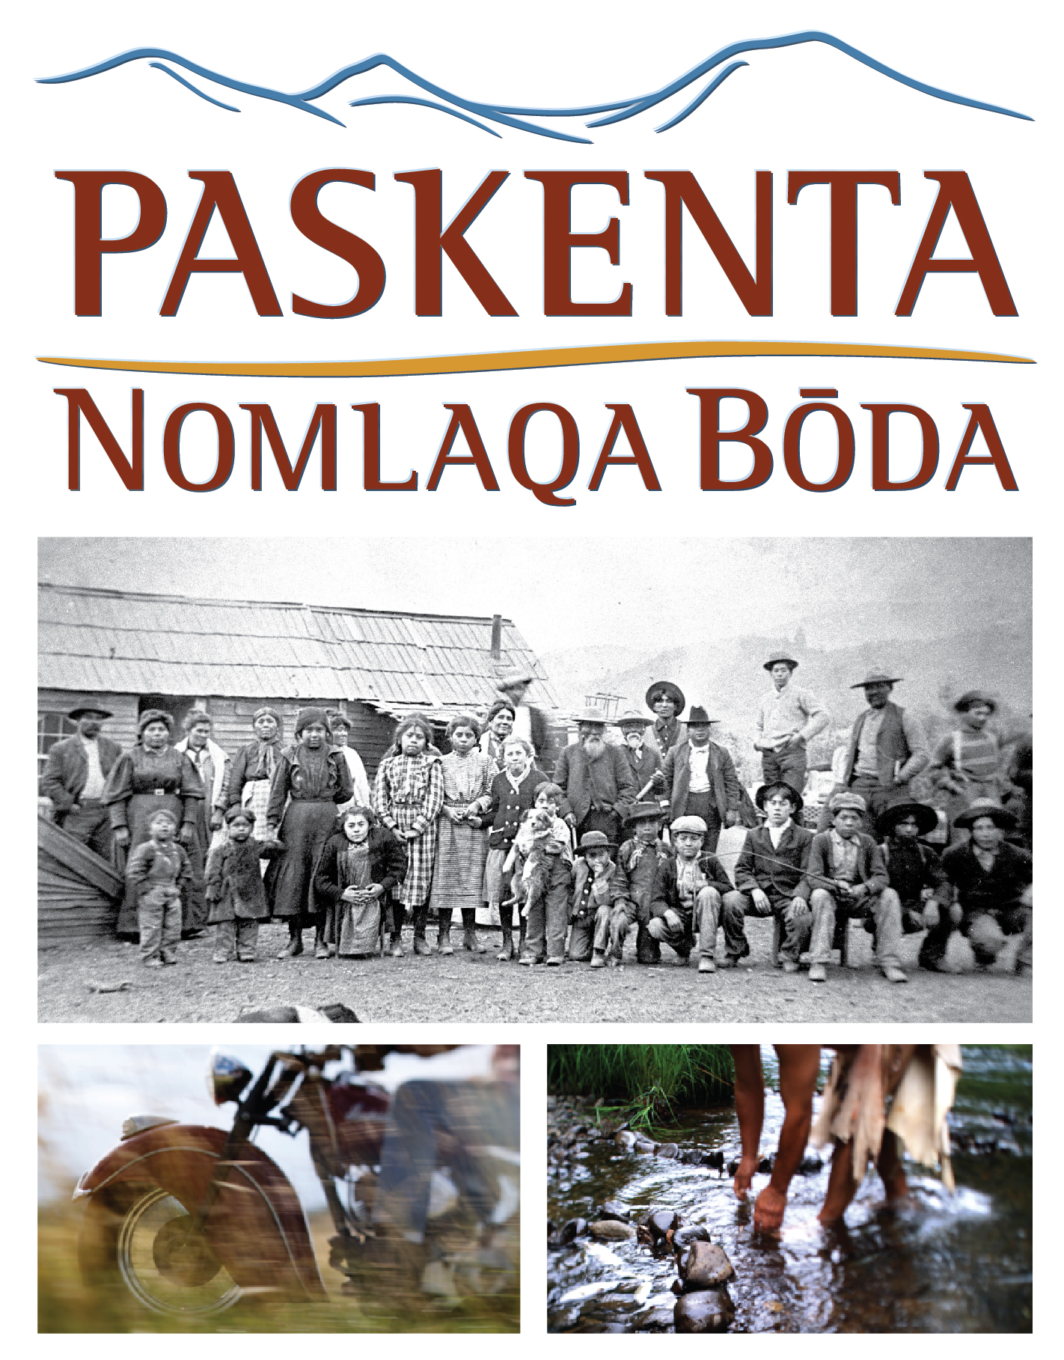
Screening at the Tulsa International Film Festival
3:45 p.m. Friday, September 23 (Q&A to follow)
6 p.m. Saturday, September 24 (Q&A to follow)
Director’s Row 3, Hyatt Regency, 100 E. Second Street, Tulsa

MEIGHAN MALONEY
Writer & Producer
Meighan Maloney has more than 20 years’ experience developing content and managing the production of documentaries and other public education projects.
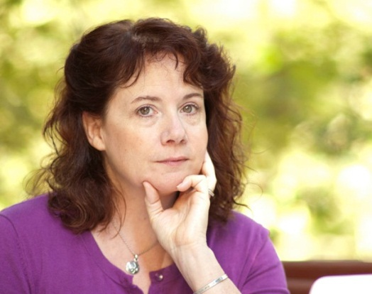
She served first as Production Manager and then as Series Manager for the Emmy Award-winning PBS series NEWTON’S APPLE and later assumed the position of Production Director for National and International Production at Oregon Public Broadcasting. In 2000, she designed and launched a new department at OPB, Educational Media Production, where she led a team in the development and production of numerous large-scale private and government-funded educational projects.
Meighan has been the Executive Producer for more than $16 million in educational video projects since 2000, consistently bringing them in on time, and on budget. She has garnered multiple awards including three Tellys and the Gold Award in the Chicago Film Festival for the series American Passages.
Meighan is the co-founder and Executive Producer for Dawson Media Group, where she oversees the production of numerous mission-based media projects.
In addition to her media work, Meighan is a member of the Board of Directors for Painted Sky, a Native American performance group based in Portland, Ore.

