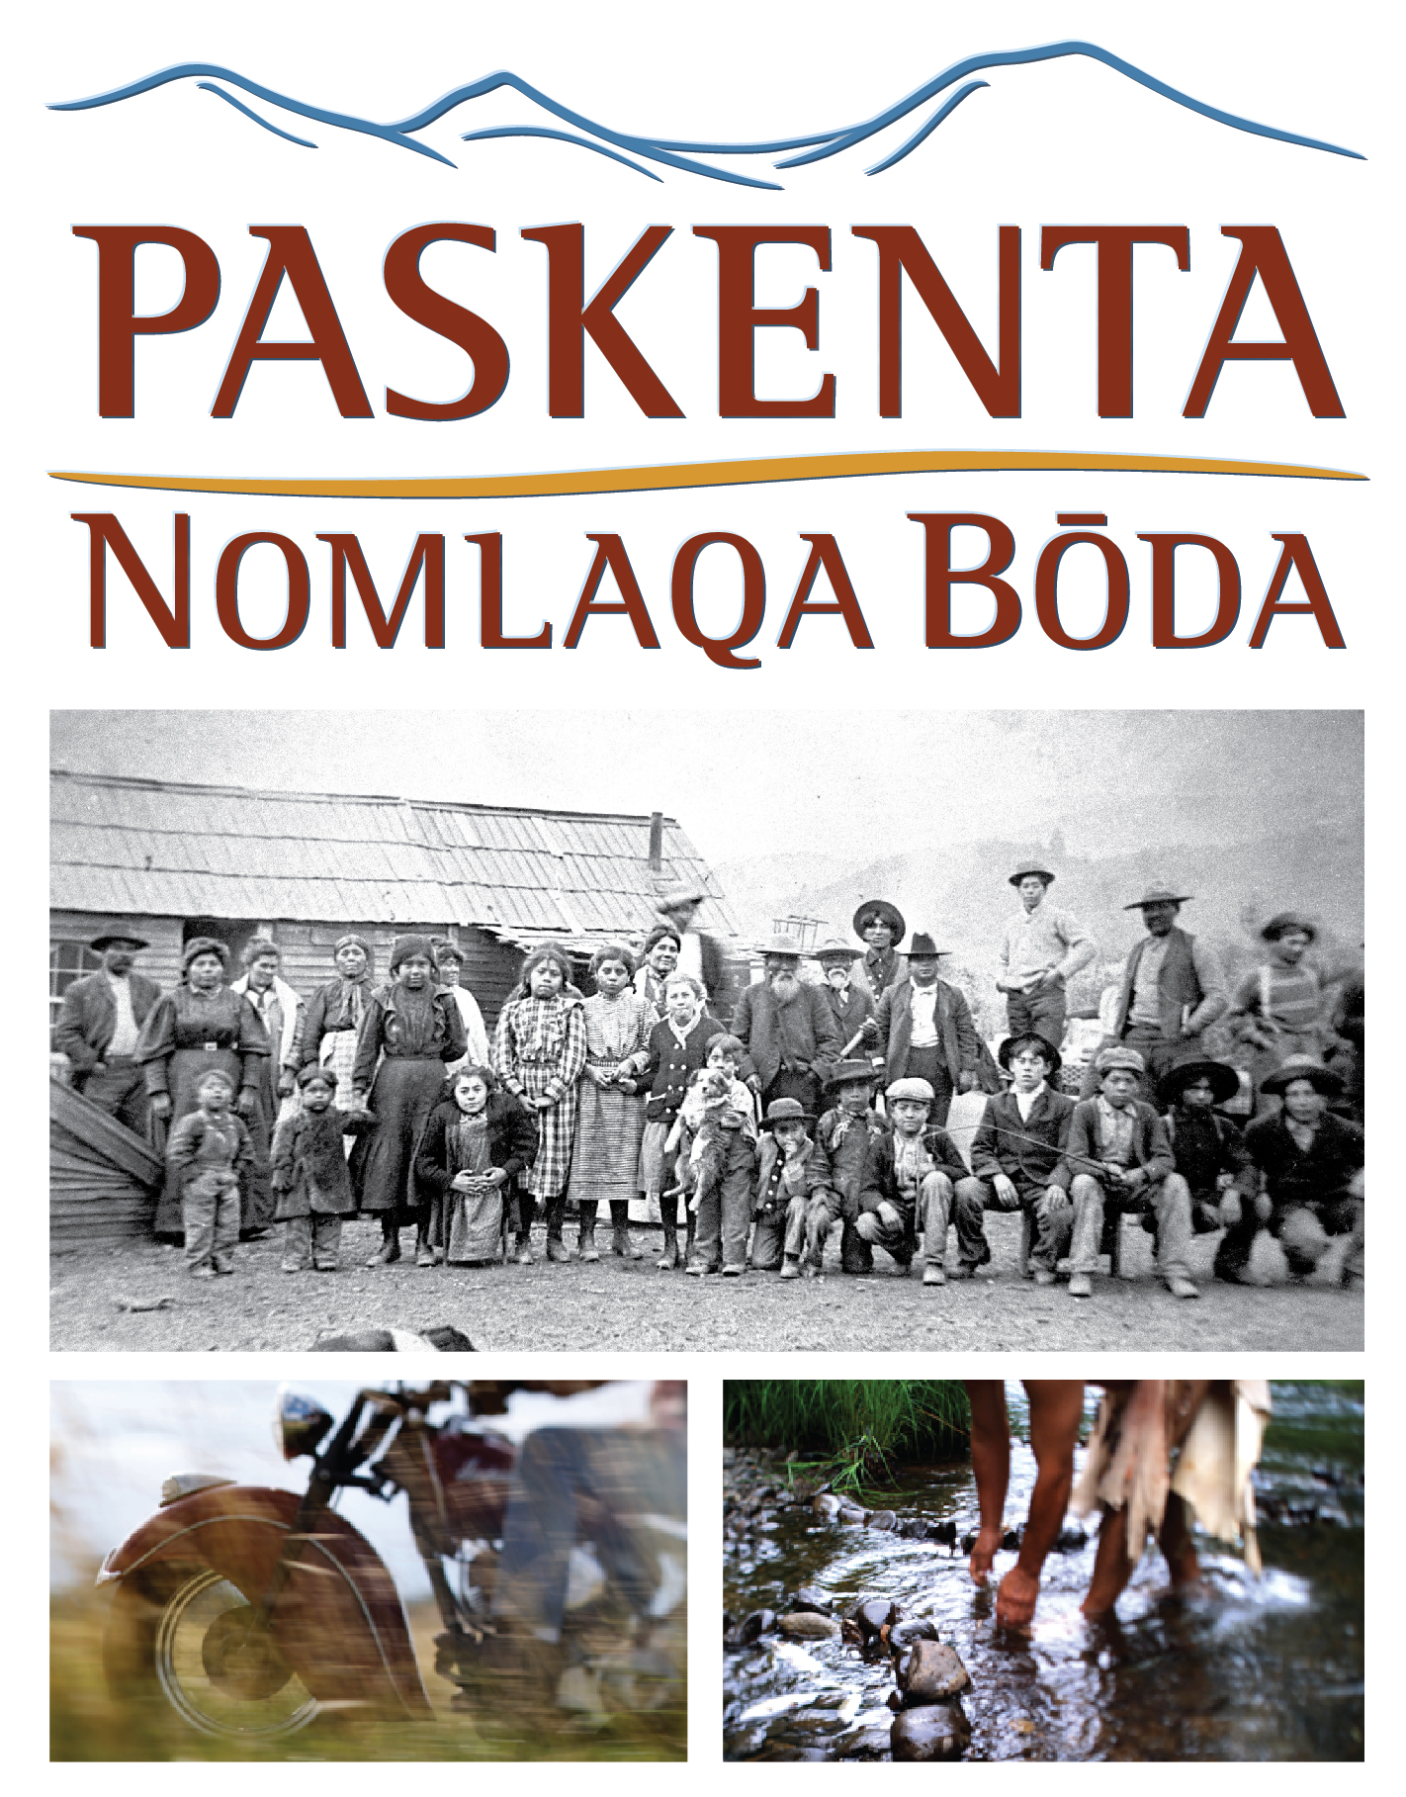
Screening at the Tulsa International Film Festival
3:45 p.m. Friday, September 23 (Q&A to follow)
6 p.m. Saturday, September 24 (Q&A to follow)
Director’s Row 3, Hyatt Regency, 100 E. Second Street, Tulsa

THE NOMLAKI
The Paskenta Band of Nomlaki Indians have lived in what is now Tehama County, California, for countless generations. Although the influx of white settlers dramatically altered the environment and many aspects of the Tribe’s traditional ways of life, the Paskenta Band has always maintained its own culture and ties to this region.
In the 1950s, the federal government terminated recognition of hundreds of Indian tribes in a misguided attempt to force assimilation. The Paskenta Band suffered this fate in 1959, and its Rancheria was sold to private parties. Despite the denial of federally recognized tribal status, the Paskenta Band maintained its tribal identity and culture while it worked for restoration as a Native American tribe. Finally in 1994, the federal government restored the Paskenta Band of Nomlaki Indians to full tribal status.
Since then, the Tribe has moved quickly to develop a strong, diverse economic base for its 240 members and surrounding communities. In 2000, theTribe acquired a 2000-acre reservation near Corning, California.

